 | 한국식품영양과학회 학술대회  Reservation form |  | 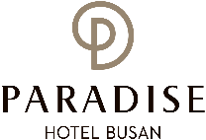
*Check In Date: 2021.10. |  | *Check Out Date: 2021.10. | 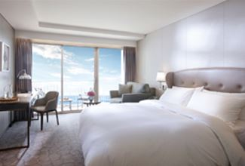  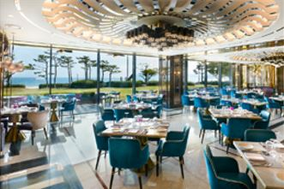  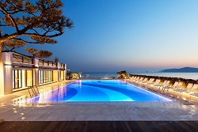
*No. of Persons:
*Name:
*Telephone: |  | *E-mail:
*GUARANTEED CREDIT CARD
Credit Card Type: ☐Etc. ☐Visa ☐Masters ☐Amex (4Digit-number : )
Expiry Date:
Credit Card Number:
Card Holder’s Name:
ROOM TYPE (Main Bldg/33m^{₂}) |  | *SPECIAL ROOM RATE | OTHERS RATE
CITY VIEW |  | ☐ KRW 205,700 (Double Bed)  ☐ KRW 205,700 (Twin Bed) | Breakfast Buffet  KRW 42,000/Pers (On Site)  1F. On the Plate (06:30~10:00)  ☐ Extra Bed/Bedding  KRW 72,600/Night
DELUXE OCEAN VIEW |  | ☐ KRW 266,200 (Double Bed)
DELUXE OCEAN TERRACE VIEW |  | ☐ KRW 290,400 (Double Bed)  ☐ KRW 290,400 (Twin Bed)
* SURCHARGE FOR THE WEEKEND: Friday(KRW 48,400), Saturday(KRW 96,800)
* SURCHARGE FOR THE ANNEX BLDG: KRW 24,200
* The rates above are non-commissionable, and they are Inclusive of 10% Service Charge and 10% Tax.
* The rates above are Not Included breakfast.
* Check-in time is 3p.m. Check out time is 11:30 a.m. (If you pass the check-out time, the following rates will apply)
Until 3pm: 50% of the room rate, After 3pm: 100% of the room rate
* FREE Benefits: Ocean pool, Fitness Club, Business Center, Play Lab, Kids Village, Internet Wifi, Parking, Amenity
* 50% Special Discount on admission to Sauna and Outdoor hot spring ‘Cimer’
* The spa facilities (Ocean pool, fitness club, Sauna, Cimer) are closed on the fourth Wednesday of every month.
CANCELLATION POLICY
* If you do not cancel on time, the hotel has the right to claim all room charge, which would be deducted from your guaranteed credit card. Cancellation or No-Show after the room reservation is being charged as below.
- From 2days(18:00) to 1day(18:00) prior to Arrival date: 50% of the Room charge
- From 1day(18:00) or less prior to Arrival date : 100% of the Room charge

상기 예약과 관련한 취소규정에 동의하며 아래의 서명으로 예약을 요청합니다.
2021년 월 일 / 성명 : (서명)
Please send your reservation form to: res@paradisehotel.co.kr (Tel no. +82.51.749.2111-3)

